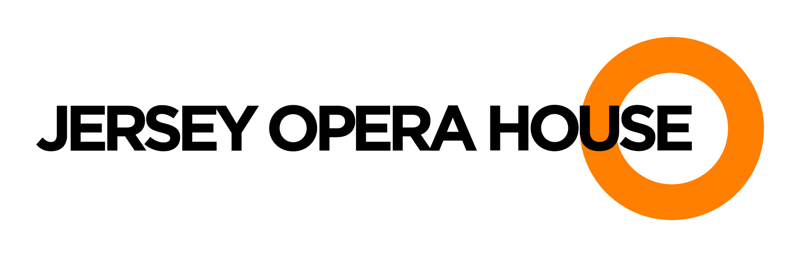

The Jersey Opera House has an exciting opportunity for an experienced individual to join our team as a

BARS & OH! CAFEBAR SUPERVISOR

In this role you will assist the Manager with all aspects of the Bars operation at the Opera House.

Experience of working in a similar environment is essential.

Closing date: 14th June 2019

For an application pack please email admin@jerseyoperahouse.co.uk

The Jersey Opera House is an equal opportunities employer and positively welcomes applications from all sections of the community.

